The impact of paper reading and digital reading on students’ understanding at UTAS - Ibra during the 2023-2024 semester
*Note paper reading and digital reading

line 1: zahra AL-HIAIL
line 2: University of Technology and Applied Sciences Ibra
line 4: City, Country
line 5: 36J1827@utas.edu.om

Abstract— Reading is very important in our society in general, and with its increasing importance, the methods used are numerous, and it may be reading on paper or electronic reading, but if we talk about the speed of comprehension and understanding, we find that with different information, the mechanism of comprehension varies (paper or electronic). In this research, I will study the extent of the impact of the mechanism. To accommodate the students of the University of Technology from various specializations through the distribution of questionnaires and interviews, then the data will be collected and then analyzed to reach a result, and through the type of information that students from different specializations study to arrive at a mechanism that is more comprehensible to technical students, and we will arrive at the reason that most students They throw the papers away after they finish them instead of using them to the next students.
Keywords—digital reading, reading on paper, Reading comprehension (Heading 1)

Introduction
1.1 Background

With the increase in digital reading and its entry into the academic and educational level, the need for students to know the effects of this reading on comprehension has emerged. and the reasons why many people take way from reading paper. and the role played by the University of Technology in the field of education and understanding students.

1.2 The Statement of Problem
With the increasing use of digital reading among university students and the loss of many of the advantages of paper reading, it has become necessary for students to know the effects of both methods on comprehension. And about what is related to the problem. The increase in digital reading increases its effects on the educational outcomes of students, and also knowing the negative effects of electronic reading makes us wonder whether these effects can be ignored, and that electronic reading enhances the understanding of university students.

1.3 The Research Hypothesis

H1: Choosing the most effective mechanism (paper and electronic) may be affected by specialization

H2: The percentage of students who use digital reading is higher than paper reading.

H3:E-reading provides greater comfort and ease of portability compared to paper reading.

H4: The biggest challenge that students face in electronic reading is eye strain, while students in paper reading face the font size.

H5: Paper reading is faster in understanding than electronic reading.

1.4 The Research Aim and Objectives

With the increase in the need for reading and the multiplicity of methods of reading with the multiplicity of studies in each method, we find that awareness among university students of a more effective method of understanding has become necessary. Students have many tasks that require understanding in their academic and practical lives. Therefore, this research will compare the effect of digital reading and paper reading on reading comprehension. We will also discover university students’ desires and opinions about digital and electronic reading methods. Which leads to knowing the factors that influence their choices in choosing the reading path. And also knowing the benefits and drawbacks of each method. We will know what are the obstacles facing students in both methods and know some of the solutions that students will present that contribute to raising their academic level.

1.6 Benefits to Oman
It is known that the method used in reading affects students’ understanding. If the method used in reading is faster in comprehension, this leads to raising the level of learning at the institution and achieving the goal with which the institution was established in Amman.

2.2 Related Literature

Chapter 2: Literature Review

2.1 Introduction

This research addresses a social phenomenon, which is the impact of paper and electronic reading questions on UTAS students. The pressure that students receive makes them ask in the best way to quickly understand. Then, most of the reasons for academic failure are students’ unwillingness to study. His inability to understand what is written. Therefore, in this research, we will try to examine the obstacles to both path

2.3 Summary and Implications
 | Research 1 | Research 1 | Research 1 | my
Title | Reading linear texts on paper versus computer screen: Effects on reading comprehension[1] | On-Screen versus On-Paper Reading: Students' Strategy Usage and Preferences [2] | the impact of text versus digital text on reading comprehension among middle school students.[3] | The impact of paper reading and digital reading on students’ understanding at UTAS - Ibra during the 2023-2024 semester
Authors | Anne Mangan | Arden B. Hamer | ProQuest | me
Aim | To investigate how a technological interface affects reading comprehension in a Norwegian educational setting. | The purpose of the study was to (a) find out what reading strategies students employ in each format and (b) find out which format they prefer. | to determine the effect of reading a printed copy versus a digital computer on the comprehension of large students | compare the effect of digital reading and paper reading on reading comprehension
Methods | Two groups of students were randomly assigned to read two texts totalling between 1400 and 2000 words in print, while the other group read the same texts in PDF format on a computer screen. Additionally, tests were given on vocabulary, word reading, and reading comprehension. To find out how much the students' reading modality would affect their reading comprehension test scores, a multiple regression analysis was performed. | A survey was conducted with 237 accomplished students who were enrolled in advanced reading-intensive courses. | the method of dividing students into groups in a comprehensive manner. Some had a total paragraph in it, and the other group had the same paragraph, but it was electronic. Then he assigned them the same time, then distributed the same questions to each group. | Questions and interviews
Results | When it came to reading comprehension, students who read books in print outperformed those who read them digitally. | strategy-use was somewhat determined by the format, but that students overwhelmingly preferred to read and study on paper. | the High of the paper students was slightly less compared to the grades of the students in the electronic | It will be known later

The literature review paints a complex picture of the impact of digital versus paper reading methods on undergraduate reading comprehension and reading engagement. While digital reading has certain benefits, there are still issues and concerns that require more research. The study highlights areas where further research is needed, such as additional studies specifically focusing on undergraduate students, considering contextual factors and using rigorous methodologies. This study seeks to expand the literature by bridging these knowledge gaps and providing evidence-based recommendations to improve undergraduate reading experiences and inform instructional practices.

Chapter 3: Research Design

3.1.1 Methodology

Correlation: Because this approach focuses on studying the relationship between variables, and in this research, I will study the relationship between digital and electronic reading methods and the level of understanding. It also measures the existence of a relationship between them. A questionnaire or survey design can also be used to collect data and analyze it statistically to determine the strength of the association between variables.

3.1.2 Research Design
In this research, we use quantitative research, as it depends on number and quantity to obtain information and statistical differences in the results of the research. Since we will in this research make the differences between methods and understanding, this method will be appropriate in research.

3.2 Participants
The participants in this research will be a sample of technical university students from different majors, students’ academic year (first, second, third, and fourth year), and ages. Since reading comprehension mechanisms vary depending on the students’ academic year, we will have approximately 53 samples. This number of samples was chosen taking into account that every academic year students take the number of samples, that is, the number of samples is different, so that these results serve the credibility of the research.

3.3 Instruments
In this research, the use of interviews is considered to provide results more accurately and quickly, because it saves time and effort, but we cannot conduct interviews for reasons including time constraints and the difficulty of asking some questions to students. Therefore, we will prepare paper and electronic questionnaires and send them to social networking sites and sites. Through these questionnaires we can collect a large amount of information to obtain research results.

 | Paper | Electronic | Both
Engineering | 10% | 16% | 3%
IT | 13% | 16% | 23%
Business | 11% | 10% | 6%
3.4 Procedure and Timeline
Tasks | Date
Choose the title | 15-10-2023
Prepare Research Title and abstract Submission | 16-10-2023
Research Proposal | 30-10-2023
Prepare base papers | 16-10-2023
- Research Methodology | 6-11-2023

AAnalysis
We will do statistical analysis. I chose this method because of its advantages, including providing tremendous results, accuracy, the ability to correlate information, and helping to make decisions faster. Because we are studying the relationship between the influence of reading methods on comprehension, that is, we will analyze a social phenomenon and obtain ratios, that is, a quantity characterized by statistical analysis. We will perform statistical analysis using the program Excel that shows the calculation of the mean, median, and percentage, and illustrate graphs. You will collect data about different specializations and ages, then divide and compare it, and calculate the previous equations using the program. The analysis method used is Pareto because it is clearer in the analysis

Ethics and Limitations
Obtaining the consent of the participants, informing the participants of the purpose of the research, the freedom of the participant to refuse or withdraw, and the researcher’s protection of the participants’ information and privacy are considered among the ethics to which the research adheres. But if we come to ask what are the obstacles or obstacles that the researcher will face, we find that they are many. Including choosing only a specific sample, despite the differences in cultures, ages, etc., and since when the researcher obtains the results of the research, he generalizes this result to the group he is studying, there will be another problem, which is that the results obtained by the researcher are incorrect, and the researcher may face the same problem as well. But with the other reason, like the participants' responses, it is not true, as one tends to be a perfectionist in all aspects of life. Also, the study may not include studying the external factors that affect understanding, such as motivation and others. Also, with the emergence of new digital technologies and the development of technology, the results may become outdated and less important.

Quistiones and Rresulta
Q1. Academic specialization:

Q2. What medium do you use most for reading?

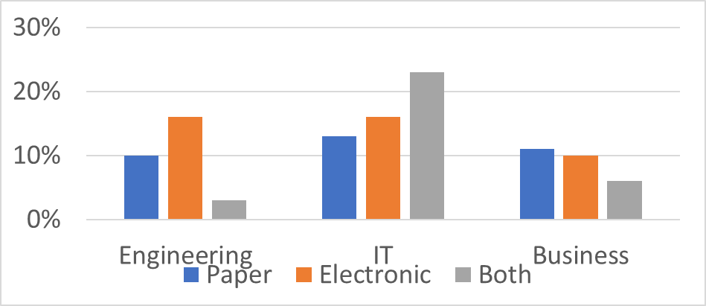
Mean | StDev
17.666 | 9.74
Q2: What medium do you use most for reading?
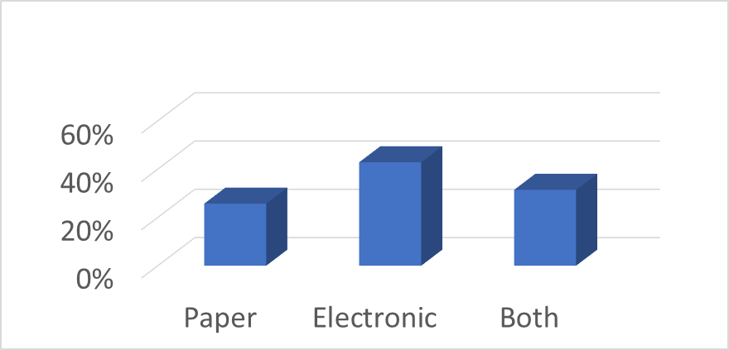
Paper | Electronic | Both
26% | 43% | 31%

Q3. What factors influence your choice of reading medium?

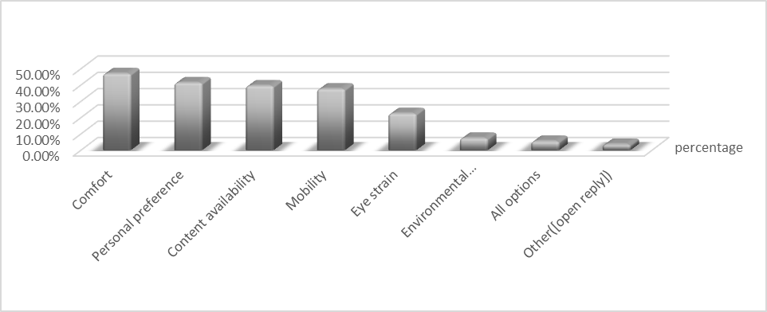
Ability to search and navigate | 41%
Size and weight | 40%
Interaction and commenting restrictions | 40%
All options | 14%
Other (Open Reply) | 1%
Comfort | 47.10%
Personal preference | 41.50%
Content availability | 39.60%
Mobility | 37.70%
Eye strain | 22.60%
Environmental considerations | 7.50%
All options | 5.60%
Other ([open reply]) | 3.70%
Q4. What challenges, if any, do you face when reading digitally?
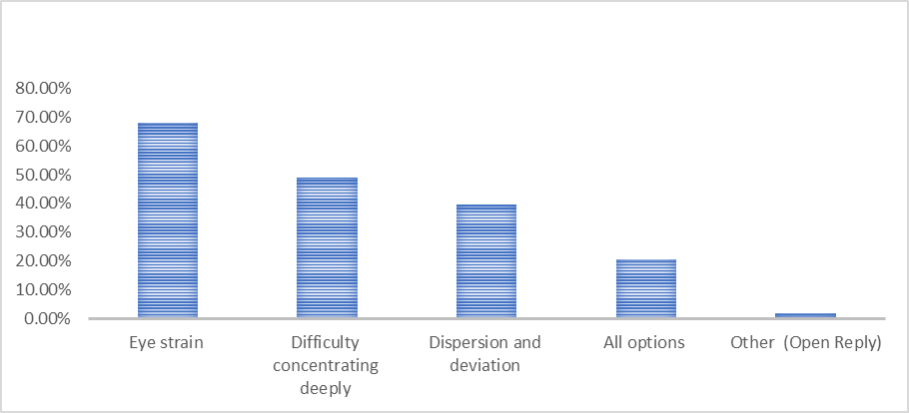
Eye strain | 67.90%
Difficulty concentrating deeply | 49%
Dispersion and deviation | 39.60%
All options | 20.70%
Other (Open Reply) | 1.80%

Q5. What challenges, if any, do you face when reading on paper?

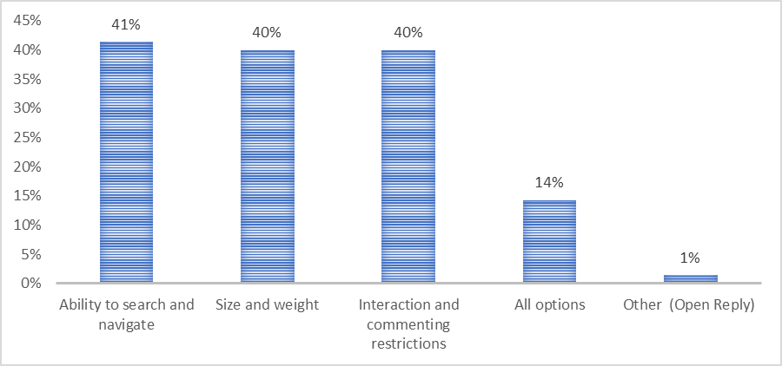

Q6. How to evaluate your reading comprehension (paper and electronic)
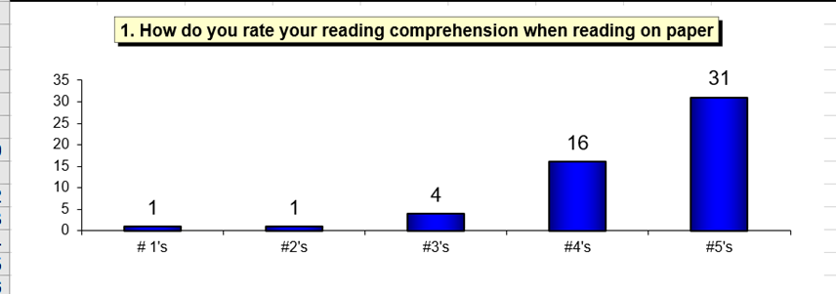

1=Strongly Disagree 2=Disagree 3=Neutral
4=Agree 5=Strongly Agree

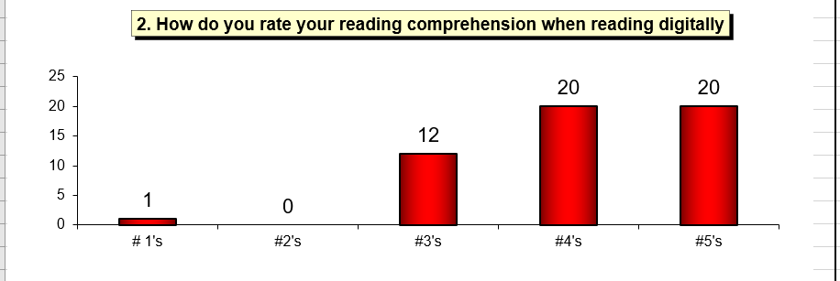
1=Strongly Disagree 2=Disagree 3=Neutral
4=Agree 5=Strongly Agree
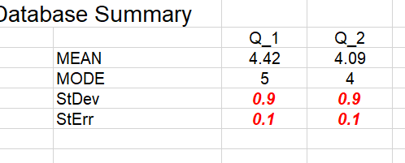

Q7: In your opinion, which medium (paper or digital) most enhances your reading comprehension?
Paper | Electronic | no different
43% | 29% | 29%
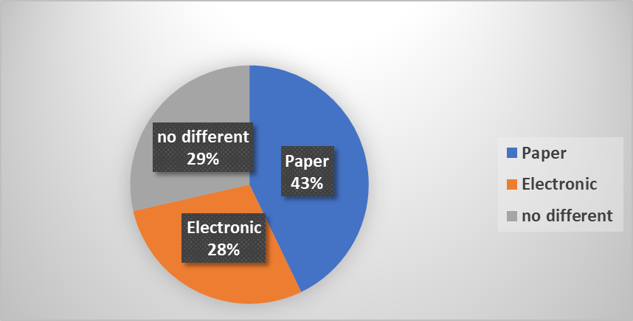

FINDINGS:

1.The majority of participants from the Engineering specialization preferred e-reading.
2. The majority of participants from the IT specialization preferred both methods (paper and digital).
3. The majority of participants from the IT specialization preferred paper reading.
4. The majority of participants use electronic reading more than paper reading.
5. The two factors that most influence participants in choosing the reading medium (electronic, paper) are the trip, followed by personal preference.
6. Eye strain is the most common challenge facing e-reading participants.
7. The ability to search and navigate is the most common challenge facing paper reading participants.

8. Paper reading is more understandable for participants compared to electronic reading.

Conclusions

This study focuses on the goal of digital and paper reading methods to understand reading and educational outcomes among technical university students. Through this study, we conclude that the goal depends on many reasons, including students’ desire to read in print and electronically. We find that many students tend towards electronic reading, considering it more practical and easier to read than paper reading, while others tend towards paper reading, due to the risks to health caused by electronic reading and the speed of comprehension compared to electronic reading. We also find that this also depends on the pros and cons of both methods. We find, for example, that electronic reading is less expensive, easier to provide, and so on, while we find that it requires saving electricity. On the other hand, we find that paper reading has a real feeling in terms of touching the papers and the ease of referring to them and distinguishing them, but we find that it is more difficult when reading at night, because it needs lighting. We also find some studies indicating that reading on paper is more understandable, as it is something tangible and free of distractions. We also find that reading on paper makes planning and writing notes easier, which also facilitates understanding. Since we will conduct research, as we mentioned previously, we must adhere to the ethics of the researcher. Also, one of the implications of this research is that the university must review these methods and their impact on the results of education in the present or future. And working to take measures to reduce these risks, such as distributing paper books instead of putting them on the website and other measures that lead to effective reading comprehension and contribute to achieving educational goals.

RECOMMENDATIONS

1.Educating students at UTAS-Ibra about the potential advantages and disadvantages of using digital and paper reading.
2. Distributing books to students instead of downloading them into the module to facilitate studying the subject
3. Helping UTAS-Ibra students build their digital literacy skills by providing support and resources.

Resources:
[1]. Mangen, A., Walgermo, B. R., & Brønnick, K. (2013). Reading linear texts on paper versus computer screen: Effects on reading comprehension. International journal of educational research, 58, 61-68.‏

[2]. Hamer, A. B., & McGrath, J. L. (2011). On-Screen versus On-Paper Reading: Students' Strategy Usage and Preferences. NADE Digest, 5(3), 25-39.‏

[3]. Singer, L. M., & Alexander, P. A. (2017). Reading across mediums: Effects of reading digital and print texts on comprehension and calibration. The journal of experimental education, 85(1), 155-172.‏

IEEE conference templates contain guidance text for composing and formatting conference papers. Please ensure that all template text is removed from your conference paper prior to submission to the conference. Failure to remove template text from your paper may result in your paper not being published.

